- Write a java program to implement the following process
1.a) Package with class contains static method and static block
//Sample.java
package Samplepackage.package1;
public class Sample
{
static
{
System.out.println("Static block");
}
public static void display()
{
System.out.println("Static method");
}
}
//Mainclass.java
import Samplepackage.package1.Sample.*;
class MainClass
{
public static void main(String args[])
{
display();
}
}

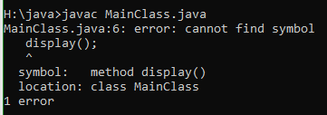

1.b) import as static import for the particular method and call the static method

//Mainclass.java
import static Samplepackage.package1.Sample.*;
class MainClass
{
public static void main(String args[])
{
display();
}
}

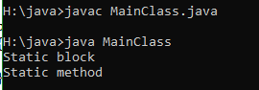

- Write a java program to implement the following process
2.a) Package with class contains public constructor.

2.b) import the class and call the constructor.

//Sample.java
package Samplepackage.package1;
public class Sample
{
public Sample()
{
System.out.println("constructor");
}
}
//Mainclass.java
import Samplepackage.package1.*;
class MainClass
{
public static void main(String args[])
{
Sample s=new Sample();
}
}

- Write a java program to implement the following process
3.a) Package with class contains protected constructor.
3.b) import the class and call the constructor.
//Sample.java
package Samplepackage.package1;
public class Sample
{
protected Sample()
{
System.out.println("constructor");
}
}
//Mainclasss.java
import Samplepackage.package1.*;
class MainClass extends Sample
{
public static void main(String args[])
{
MainClass m=new MainClass();
}
}

- Write a java program to implement the following process
4.a) Package with abstract class contains abstract method declared as default.
4.b) import the class and override the abstract method.
//Sample.java
package Samplepackage.package1;
abstract class Sample
{
abstract void display();
}
//Mainclass.java
import Samplepackage.package1.*;
class MainClass extends Sample
{
public void display()
{
System.out.println("display method");
}
public static void main(String args[])
{
MainClass m=new MainClass();
m.display();

}
}
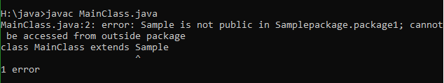

- Write a java program to implement the following process
5.a) Package with abstract class contains abstract method declared as protected.
5.b) import the class and override the abstract method.
//Sample.java
package Samplepackage.package1;
abstract public class Sample
{
abstract protected void display();
}
//Mainclass.java
import Samplepackage.package1.*;
class MainClass extends Sample
{
public void display()
{
System.out.println("display method");
}
public static void main(String args[])
{
MainClass m=new MainClass();
m.display();
}
}
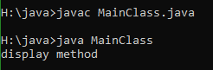
6. Write a java program to implement the following process
6.a) Package with abstract class contains abstract method declared as public.
6.b) import the class and override the abstract method.Sample.
//abstract method
package Samplepackage.package1;
abstract public class Sample
{
abstract public void display();
}
//Mainclass.java
import Samplepackage.package1.*;
class MainClass extends Sample
{
public void display()
{
System.out.println("display method");
}
public static void main(String args[])
{
MainClass m=new MainClass();
m.display();
}
}
